AI Agent for Documentation and Summation

Software Architecture
Version 1.0

Team Members
Shar Min
Abhisar Anand
Brayan Cano
Myles Edwards
Ali Mutlek
Dhyan Patel

Revision History
Date | Version | Description | Name
11/07/2025 | 1.0 | Software Architecture Design | Shar Min
12/07/2025 | 1.1 | Software Architecture Design | Ali Mutlak

Website Architecture:
This section explains how users see and use our system through the web dashboard. Our project has three main user types for now: Doctor, Admin, and Patient. Each user logs in to the same dashboard but has slightly different views and actions.

Registration and Login
The Admin acts as a default account, which can then create Doctor/Patient accounts for other users.
Admin View
The Admin is responsible for managing users:
- View all statistics cleaned of privacy risks
- Edit/Delete/Create accounts with varying permissions
- View account associations
Doctor View
Main features available to a doctor include:
- Record a patient conversation directly from the dashboard.
- Upload audio files from a previous visit.
- Upload scanned medical documents to be read by OCR.
- View full transcripts of visits.
- View SOAP-style visit summaries (Subjective, Objective, Assessment, Plan).
- Print or download a patient summary document.

Doctors use these tools to reduce the time spent on manual documentation while improving the clarity and completeness of patient notes.

Patient View
The Patient View allows patients to securely access and review information related to their own medical interactions. This role has the fewest permissions and focuses on clarity and privacy.
Main features available to a patient include:
- View personal visit summaries and transcripts shared by their doctor.
- Download or print their own medical visit notes.
- Review SOAP summaries that describe what was discussed and planned during their visit.
- Optionally provide feedback or corrections on transcription errors.
- Update contact information and account password.

Sequence Diagram (Login/Registration):
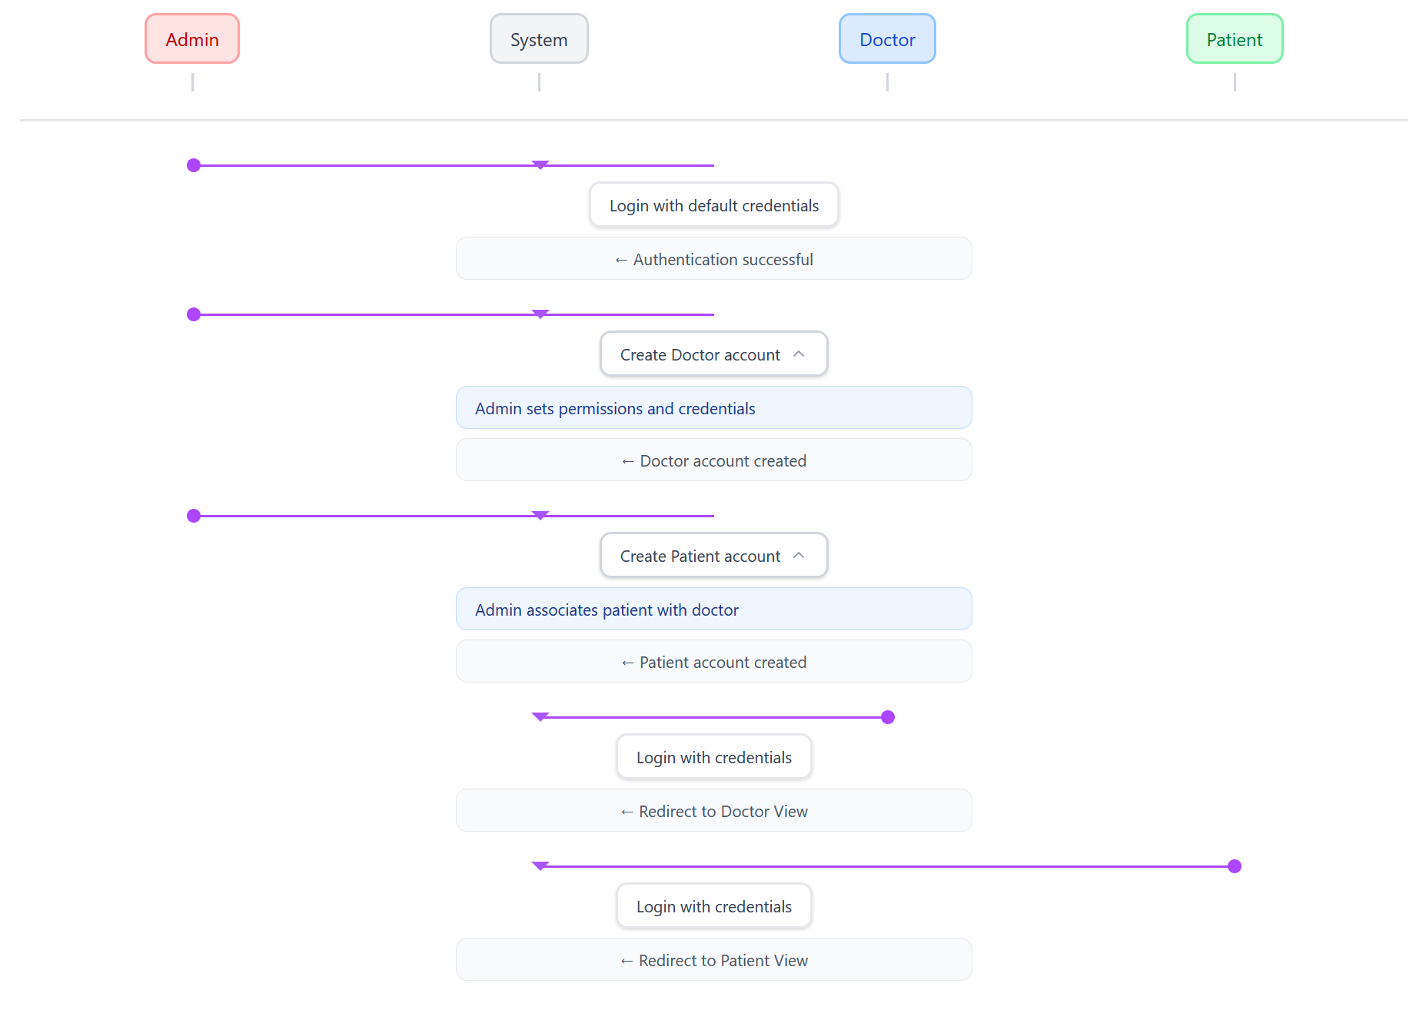

Sequence Diagram (Admin):
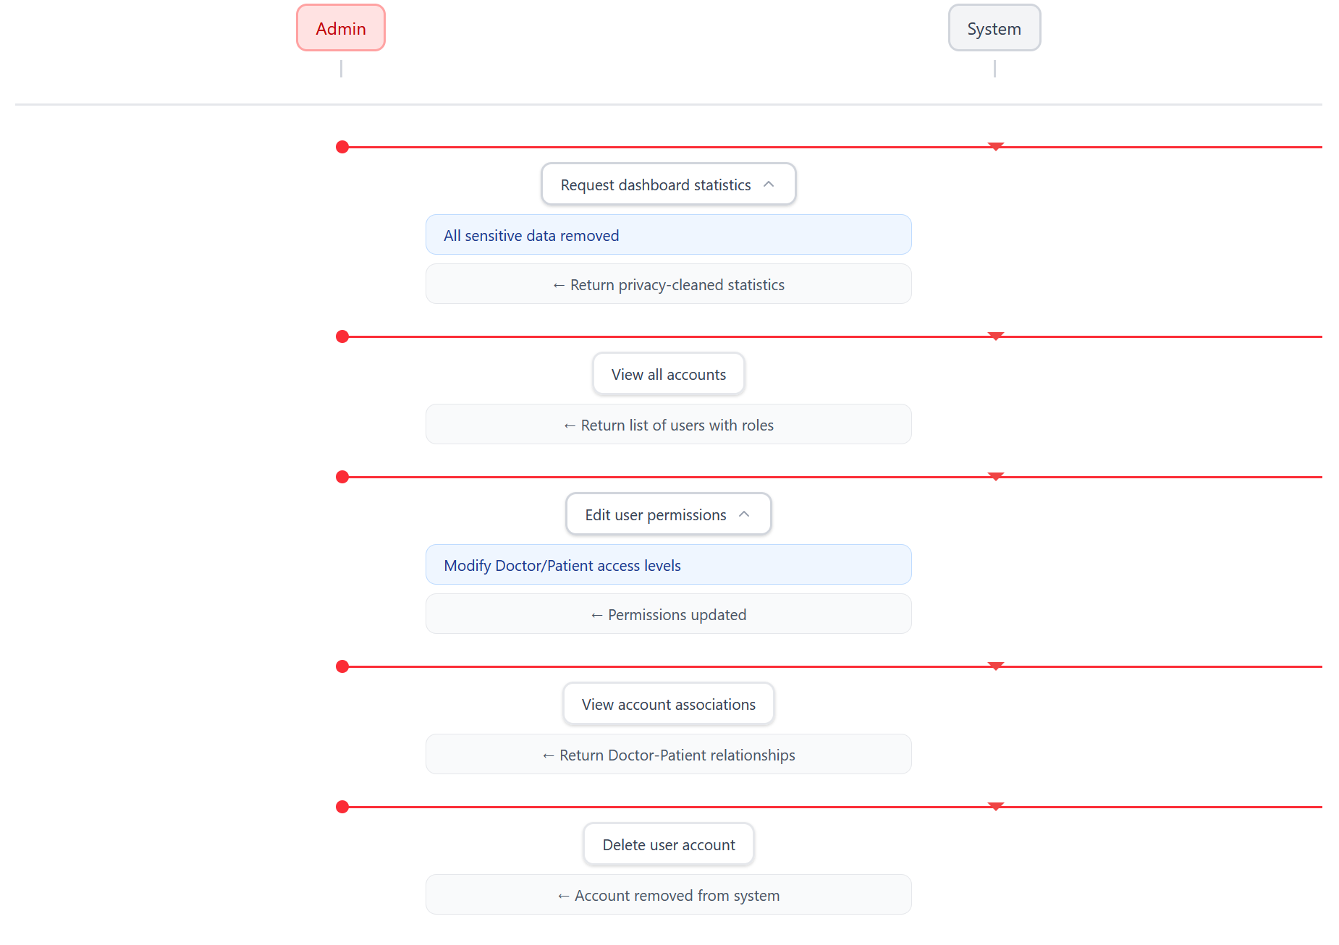
Sequence Diagram (Doctor):
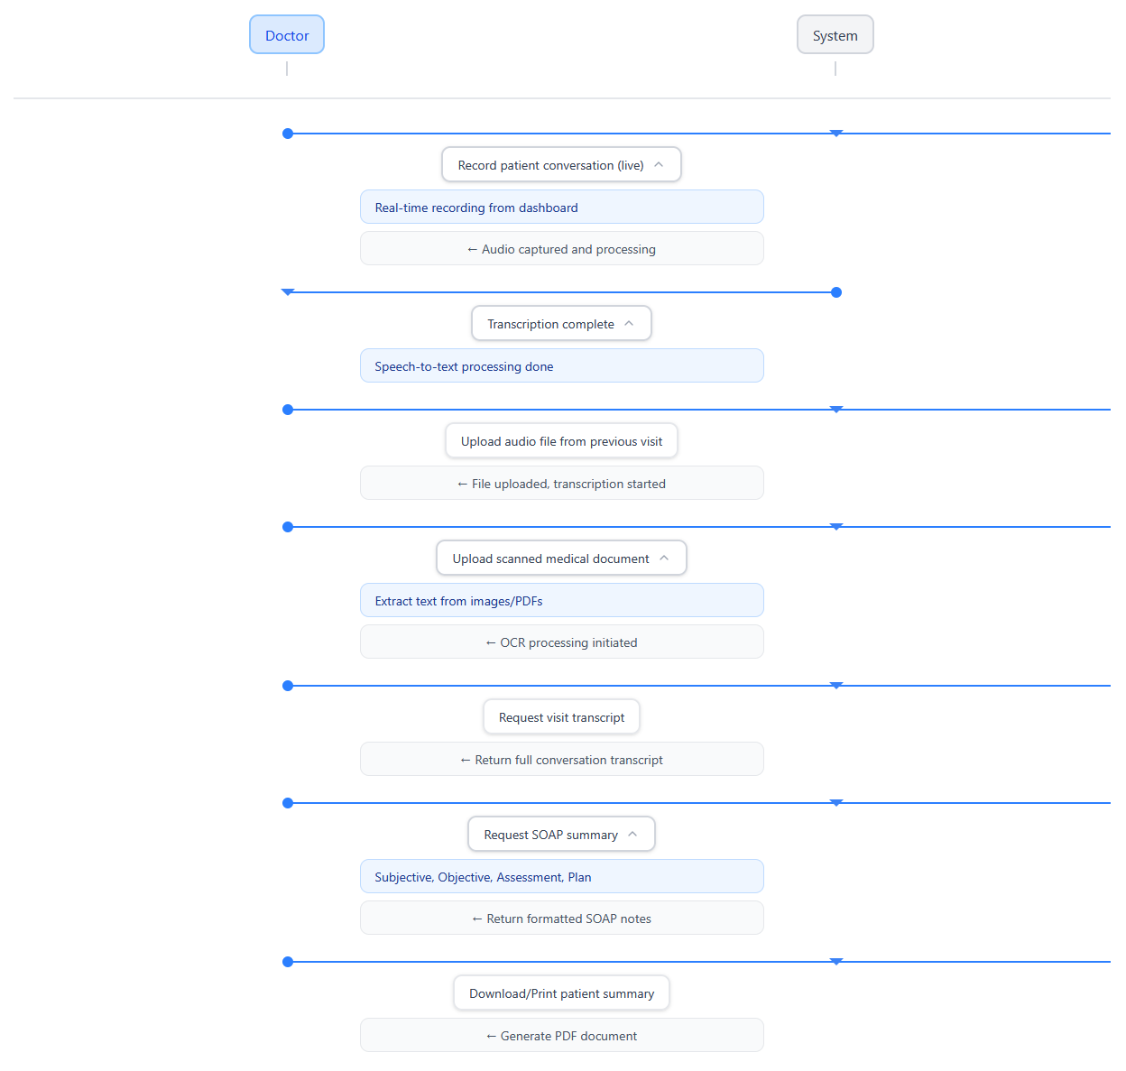
Sequence Diagram (Patient):
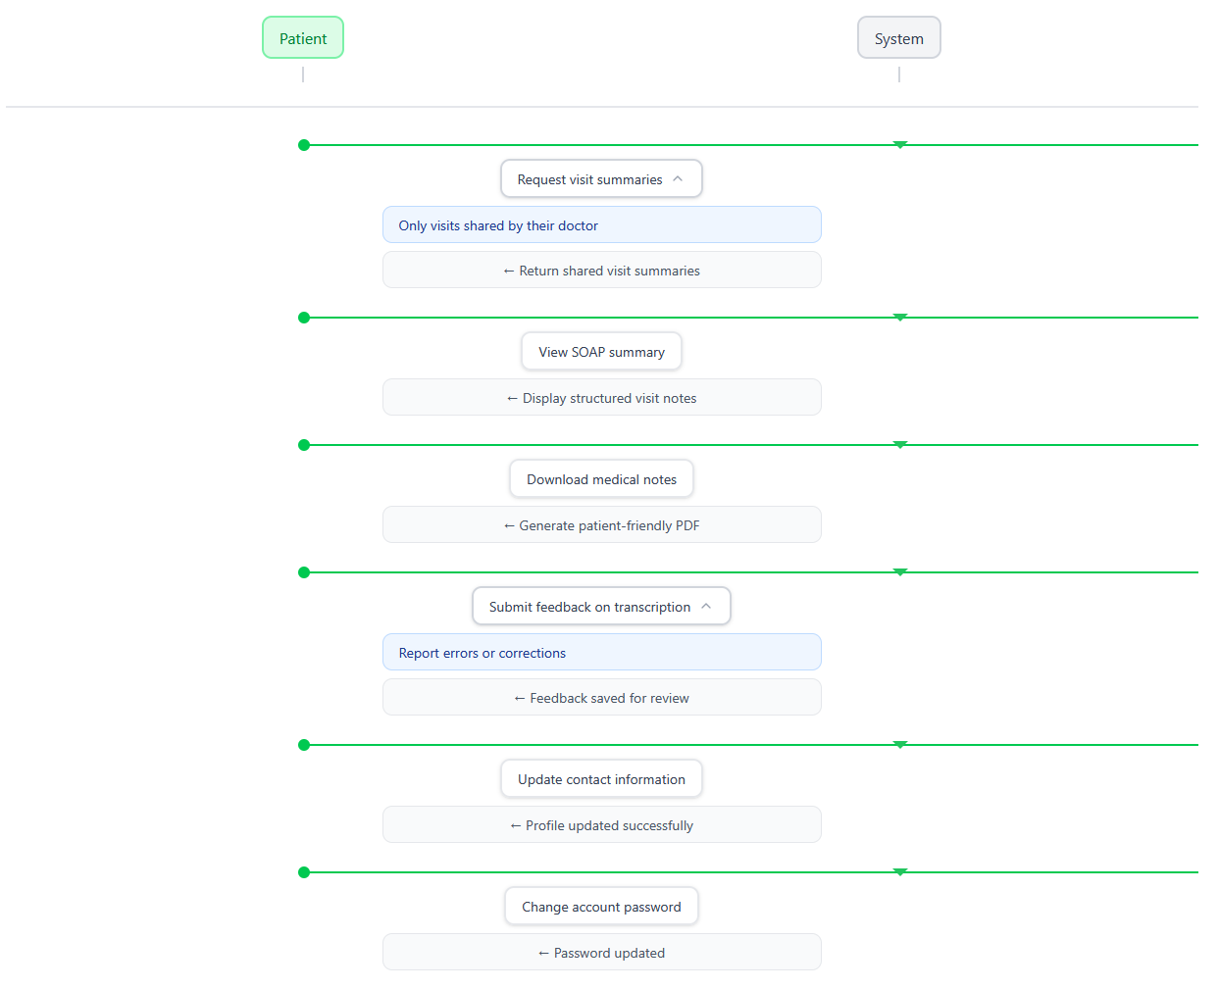
System Model:
The system follows a three-part web architecture.
Users interact with the Client-side Dashboard in a web browser. The dashboard communicates with the AI Server on the backend, which processes AI tasks and stores results in the Database.

Client-side (Dashboard)
The client-side is a web dashboard built with React + Vite.
It runs in the user’s browser and allows users to:
- Record or upload audio.
- Upload medical documents.
- View transcripts, summaries, and reports.
- Track patient or visit statistics through the dashboard interface.
This layer provides a clean, simple interface for users to interact with the system.

Server-side (AI Server)
The server-side is the main processing component of the system.
It receives audio recordings or uploaded documents from the dashboard and performs AI-related tasks such as:
- Converting speech to text.
- Extracting text from scanned medical documents.
- Generating SOAP-format summaries for clinical documentation.

The AI Server also connects to the database to store and retrieve processed files and transcripts. It ensures all information is handled securely and sent back to the dashboard for viewing.
Database (MongoDB and File Storage)
The database layer uses MongoDB to store:
- Transcripts
- OCR text
- SOAP summaries
Original audio and document files are stored in file storage on the server, and the MongoDB database keeps references to these files. This structure ensures that all patient data is easy to retrieve, organized, and securely stored.
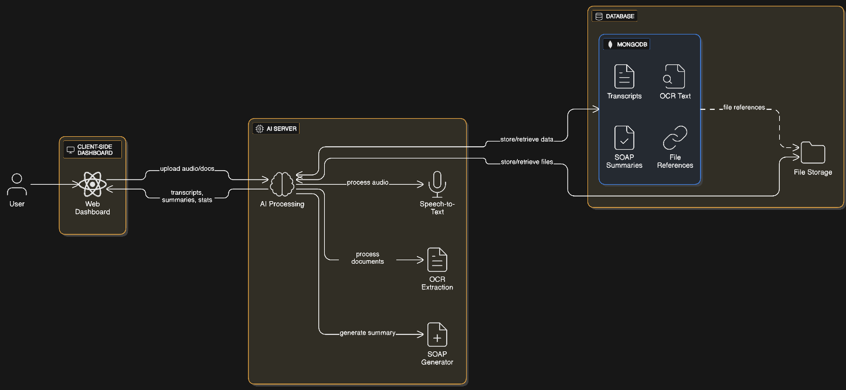
Diagram Description
In the visual System Model diagram, there will be three main components:
- Client-side Dashboard
- AI Server (Processing Layer)
- Database (MongoDB + File Storage)
Arrows will show how information moves between these parts:
- Users send files and requests from the dashboard -> AI Server processes the data -> results and summaries are stored and retrieved from the database.

